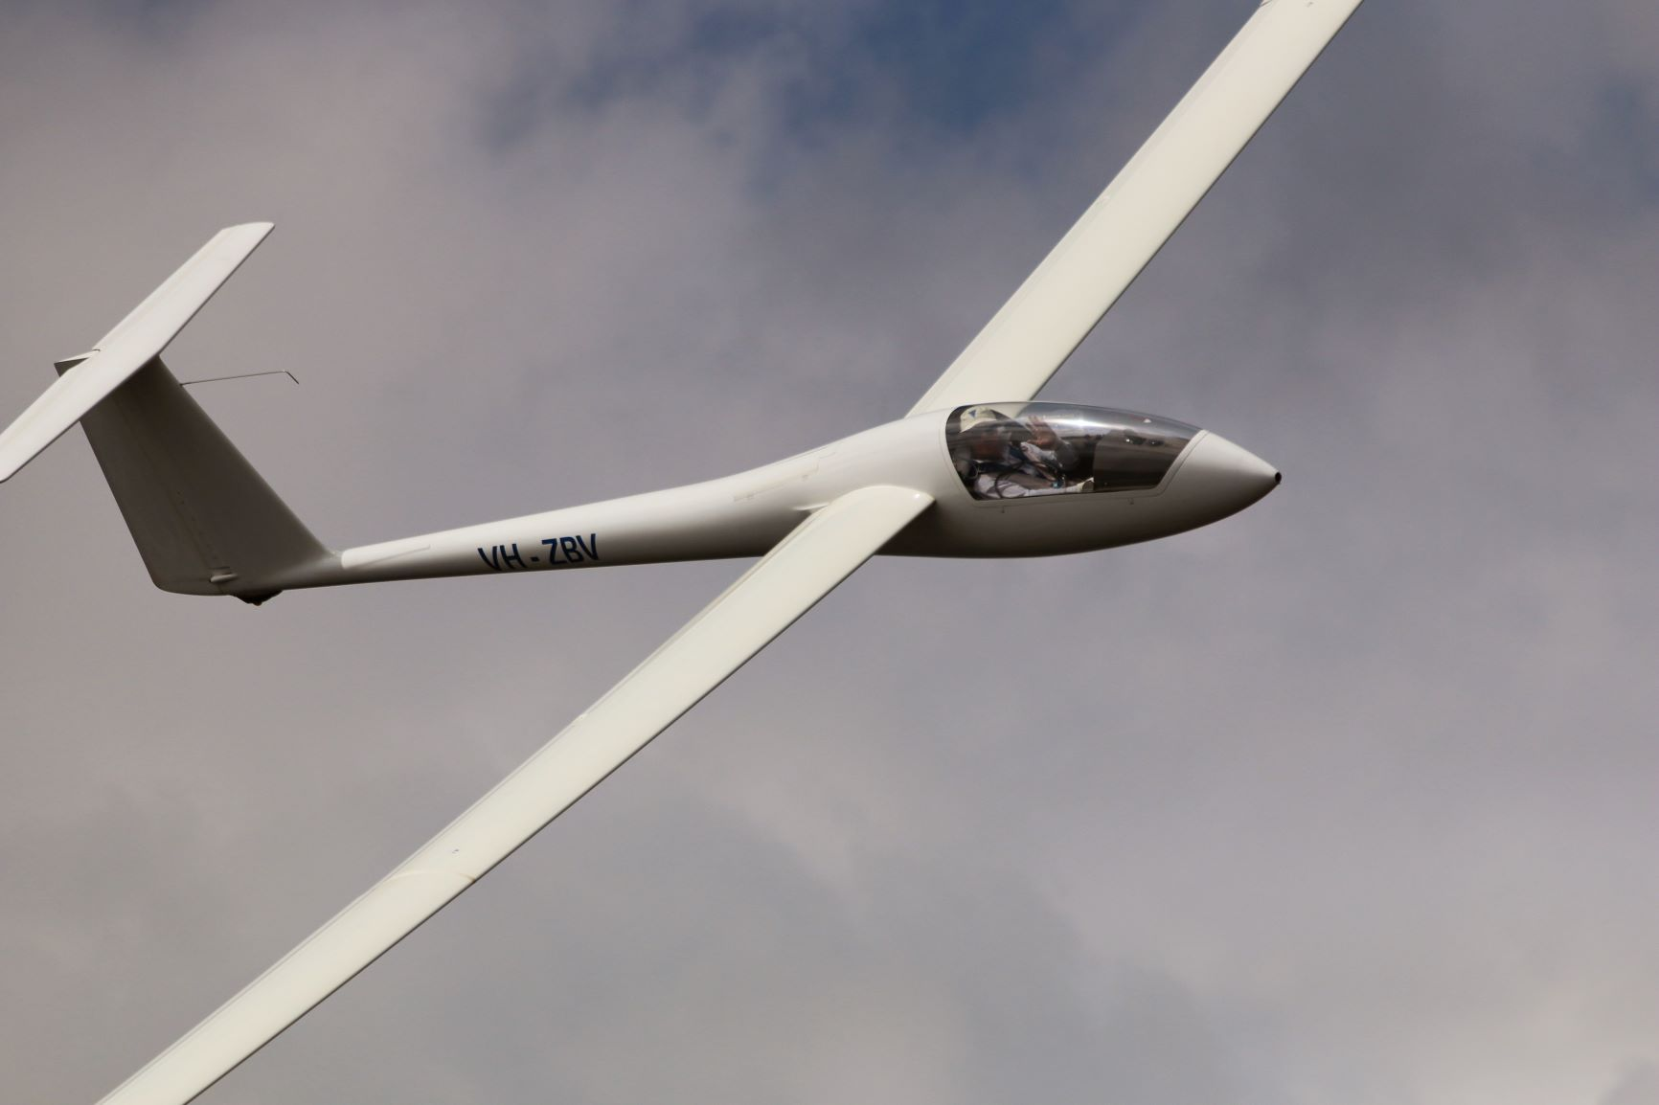
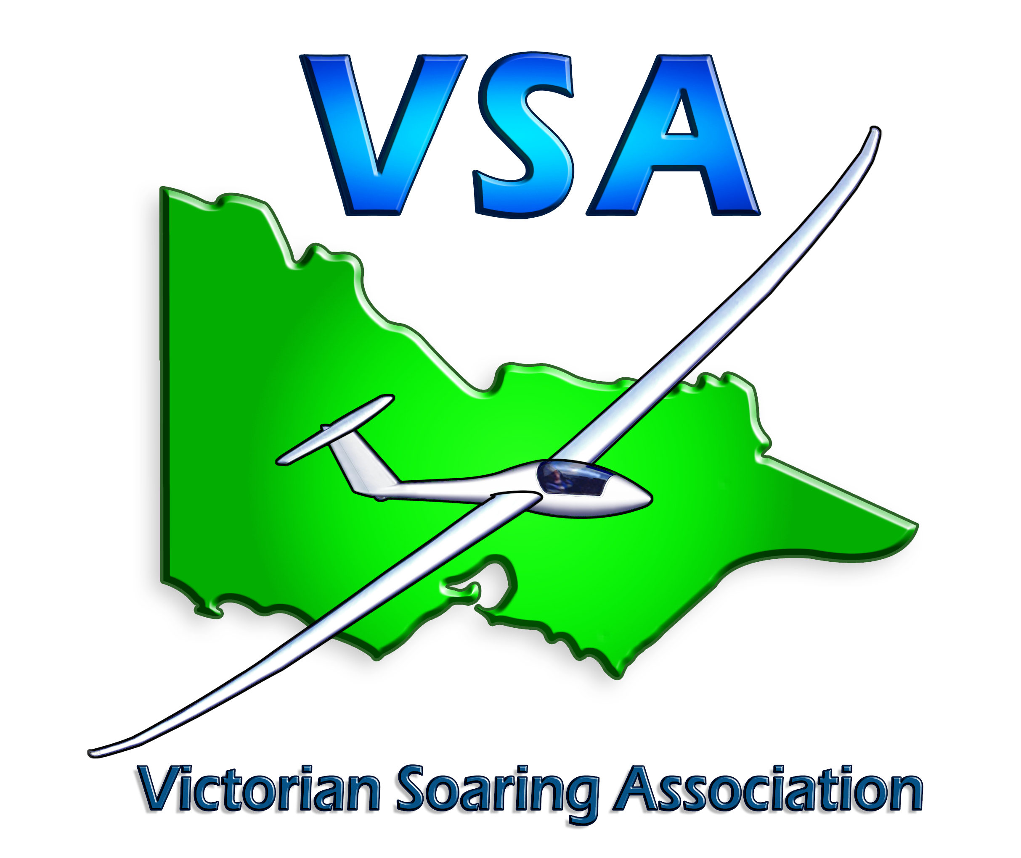

VICTORIAN SOARING ASSOCIATION

Strategic Outlook

2019

MISSION
The Victorian Soaring Association works from a base of member organizations to provide a safe environment for all people to experience the thrill of gliding and achieve lifelong enjoyment from the sport.

POSITIONING STATEMENT
We are about fostering strong clubs, encouraging enthusiastic participation by inclusion and diversity whilst maintaining robust safety systems.

OUR VALUES
- Caring and sharing
- Listening and communicating
- Respect and Fair Play
- Acceptance, tolerance and inclusion
- Responsibility
- Commitment and service

VSA VISION 2019
We are passionate advocates of self-supporting, active, engaged gliding communities.
As a partnership of clubs, we intentionally shape opportunities to make gliding in Victoria a rewarding, affordable, accessible and fun experience. Our aim is to work constructively with clubs and members to foster good governance, compliance and opportunities to develop and grow in an atmosphere of inclusion and respect and to foster the opportunity for people to be able to participate safely in a exciting adventure sport to be part of something special, worthwhile and unique.

Strong Clubs
Strong clubs come in all shapes and sizes in the VSA, they are mostly run by dedicated volunteers. The clubs are at the heart of gliding and are key to the successful development of the sport.
The VSA aims to establish opportunities by working with all clubs and in partnership with government and private enterprises to enhance club development, good governance, leadership and policies of inclusion and diversity that will lead to improved sharing of information and ideas between clubs to assist in running efficient, compliant and effective organizations.

Strong Participation
The introduction and retention of people, regardless of age, ability or background, into gliding in a way that maintains their interest and enthusiasm is vital to a healthy development and growth of the sport. The VSA aims to foster programs and opportunities to ensure the sport of gliding captures the imagination of people involved, is inclusive in its programs and provides pathways for volunteering along with participating in government initiatives and the community at large.

Safe Environment
Maintaining flying operations and aircraft airworthiness standards and safety performance is critical to the ensuring participants confidence and respect for the sport by the community at large. This is a traditional area of strength and leadership by the VSA in the Australian Gliding Community; a position we intend to maintain.
The VSA will continue to provide training, seminars and forums to facilitate the achievement of Gliding Federation of Australia and CASA MOSP and safety initiatives with reference to Target Zero, aviation safety and compliance.

