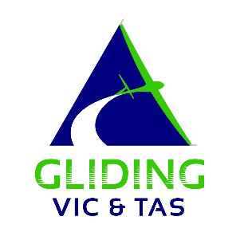

ROOKIES FLIGHT PATH
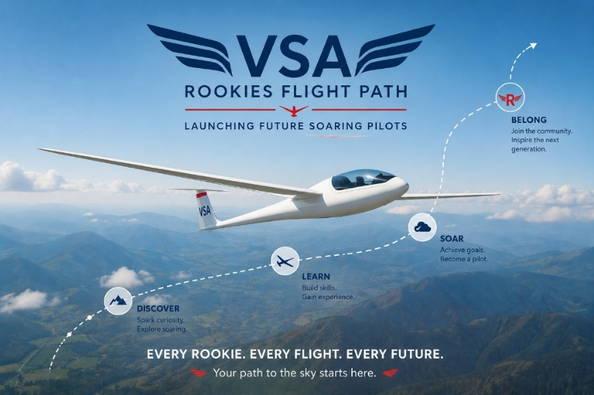
VSA Rookies Flight Path Incentive Program
The VSA Rookies Flight Path Incentive Program has been developed to support clubs in attracting, welcoming, and retaining new participants in gliding along with welcoming pilots who want to return to the sport. The program recognises that successful recruitment requires time, resources, volunteer effort, and ongoing engagement.

The objective is simple: provide clubs with a meaningful financial incentive to recruit and retain new and former members while helping grow a stronger, younger, and more diverse gliding community across Victoria and Tasmania.

Program Overview

Clubs that register as participating Rookies Flight Path Clubs will be eligible to receive a $1,000 VSA Growth Grant for each eligible Rookie who:

- Enrols in the Rookies Flight Path Program.
- Age group – 30 – 60 years of age.
- Becomes a financial member of a participating club.
- Maintains continuous membership for a minimum of 12 months.
- Completes an agreed introductory pathway within the club.
- Retention Milestone - After 12 months of continuous membership, the club becomes eligible for a $1,000 Growth Grant for each Rookie.

The grant is designed to assist clubs in further recruitment, training, mentoring, equipment, marketing, and member development activities.

Program Objectives

The program aims to:
- Increase the number of active gliding participants.
- Re-engage former glider pilots and members.
- Attract younger participants, women, First Nations people, and diverse community groups.
- Improve member retention through structured onboarding and mentoring.
- Support clubs to develop sustainable recruitment programs.
- Create a welcoming and inclusive culture across the region.

Club Requirements

Participating clubs will:

- Register as a Rookies Flight Path Club
The club commits to supporting the principles of the program and providing a positive onboarding experience.

- Nominate a Rookie Coordinator
A volunteer or committee member who acts as the primary contact for new participants and coordinates local activities.

- Provide a Structured Welcome Pathway
This may include, but not limited to:
- Welcome briefing and club introduction.
- Mentor allocation.
- Introductory flying opportunities.
- Social integration activities.
- Information sessions on training and pathways.

- Report Outcomes
Provide a brief annual report outlining:
- Number of rookies recruited.
- Number retained after 12 months.
- Activities undertaken.
- Lessons learned and success stories.

Eligible Rookies
An eligible Rookie is a person who:
- Has not been a financial member of a gliding club within the previous three years; or
- Is completely new to gliding; or
- Is returning to the sport after an extended absence and recommences membership through the program.

Funding Payment

Stage 1 – Registration
Clubs register with the VSA to join the program.

Stage 2 – Rookie Membership
The Rookie joins the club and commences flying and volunteer participation.

Stage 3 – Retention Milestone
After 12 months of continuous membership, the club becomes eligible for a $1,000

Growth Grant for that Rookie.

Use of Funds
Clubs may use grant funds for:
- Furthering the Rookie’s gliding journey and training support.
- Recruitment and marketing activities.
- Come-and-try events.
- Community engagement programs.
- Youth development initiatives.
- Instructor and mentor training.
- Club equipment and facilities.
- Diversity and inclusion initiatives.

Funds should be directed toward activities that contribute to continued membership growth and participation, either directly with the Rookie or through club initiatives that involve the Rookie.

Recognition
Participating clubs will be recognised through:
- VSA newsletters by Rookie Flight Path success stories.
- VSA website and social media.

Success Measures
The VSA will monitor in liaison with participating clubs, the following:
- Number of participating clubs and growth in regional club membership.
- Number of rookies recruited and the 12-month retention rates.
- Growth in youth and female participation.
- Long-term sustainability of recruitment activities.

Program Vision
The Rookies Flight Path Incentive Program is more than a recruitment initiative. It is an investment in the future of gliding. By rewarding clubs and Rookies that successfully welcome and retain new members, the VSA aims to build a stronger, more vibrant, and more sustainable soaring community for generations to come.

Every Rookie. Every Flight. Every Future.

